**Christopher King**

**2018141521058**

**Mechanical Design 1**

**Class Section 01**

**09/09/2020**

**Problem 1**

**Solution:**

For this question, we are asked to sketch a free-body diagram of each element in the figure. Use the equations of equilibrium to compute the magnitude and direction of all the internal forces and reactions.

1.



2.

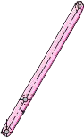

3.



4.

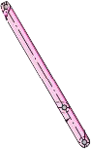

5.



From the free body diagram for the whole part, I can know that

From the free body diagram for the part 5, I can know that

From the free body diagram for the part 4, I can know that

From the free body diagram for the part 3, I can know that

From the free body diagram for the part 2, I can know that

**Problem 2**

**Solution:**

For this question, we are asked to determine the largest load P that can be applied at A.

From the free body diagram for the whole part, I can know that

From the question, I can know that

Therefore, the largest load P that can be applied at A is equal to .